# **CTF Topic: Scanning Network Using Censys.io**



# **Introduction**



Footprinting and reconnaissance involve gathering detailed information about a target system using both passive and active methods to identify vulnerabilities for penetration testing. These phases are essential for planning effective security assessments and ensuring robust defenses.

# **Tools and requirements**

censys.io

# **Link**

Link 1: <https://search.censys.io/?q=>

# **Scenario**

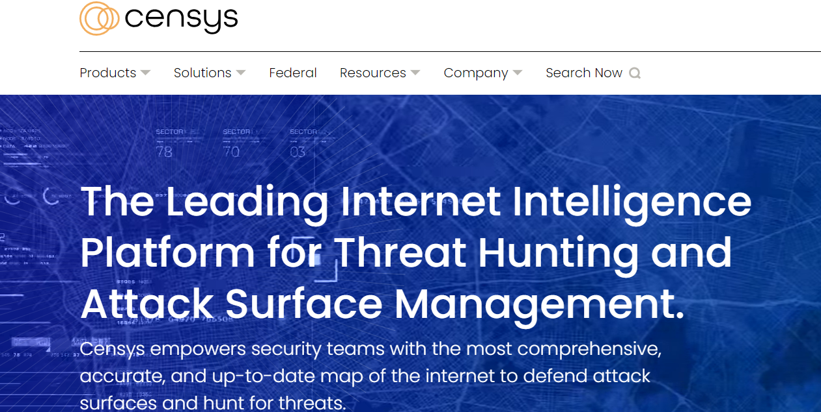

You are an IT security consultant tasked with identifying the services exposed by a client's device on the internet using Censys.io. Your goal is to determine which services are publicly accessible.

# **Process**

To begin you have to open the censys.io and search the ip-address **172.67.130.226** and the information will appear then the flag will be captured.

# **Question**

Flag 1: How many ports are running on cloudflare load balancer?

Answer: 13.

Flag Captured

Flag 2: In which country this IP domain belongs to?

Answer: United States (US).

Flag Captured

# **Hint**

